West Midlands Placement Portal (WMPP)
Dashboard Overview and KPI Logic Document
Final pack prepared to support shared understanding and consistent interpretation across the 14 Local Authorities
Prepared by: Hamant K Jakhu
Senior ICT Manager
Date: 23 June 2026

This document has been written from the perspective of the dashboard creator and is intended to explain what each dashboard page shows, how each KPI is calculated, and how users should interpret the metrics when reviewing WMPP activity.

1. Executive Summary
I have developed this WMPP Power BI dashboard pack to provide a consistent, transparent and operationally useful view of referral, offer, pending offer, draft offer and IPA activity. The purpose of this document is to explain the dashboard in plain English for colleagues across the 14 Local Authorities, while also providing the technical logic behind each key metric.
The dashboard has been designed to support both operational monitoring and strategic discussion. It separates referral demand from offer activity, separates live pending offers from draft activity, and clearly identifies where workflow gaps exist between accepted offers, IPA creation and IPA completion.
A key principle throughout the dashboard is that measures are calculated using distinct identifiers wherever possible, such as referral ID, offer ID and IPA ID. This reduces the risk of double counting and supports a clearer interpretation of performance.
Dashboard area | Main question answered | Primary use
Referrals Overview | How much referral demand exists and what is the current referral status? | Referral demand monitoring and lifecycle overview
Offers Overview | How is the market responding to open referrals? | Offer activity, provider participation and outcome monitoring
Pending Offers in Progress | Which pending offers are ageing and where is intervention needed? | Operational backlog and provider follow-up
Draft Offers | Are draft offers being progressed or left inactive? | Process accountability and hidden backlog identification
IPA Overview | Are accepted offers progressing into created and completed IPAs? | Workflow conversion and placement formalisation

2. Dashboard Methodology and Reporting Principles
The dashboard uses a structured reporting approach so that users can distinguish between referral-level metrics, offer-level metrics and IPA-level metrics. This distinction is important because one referral can have multiple offers, and one accepted offer may or may not yet have progressed to an IPA.
Principle | Explanation
Distinct counting | Metrics use DISTINCTCOUNT where appropriate, ensuring that referrals, offers and IPAs are counted once at their relevant grain.
Latest offer record | Offer-based measures use fact_offer[Is_Latest_Record] = 1 to avoid counting historical versions of the same offer.
Flow-based referral reporting | Referral status KPIs are based on referrals created in the selected reporting period and categorised by current status.
Date relationship control | Referral measures use USERELATIONSHIP between dim_date[Date] and dim_referral[referral_date_only] to apply the selected date range using the referral date.
Operational ageing | Pending and draft measures use age bands to identify healthy, at-risk, delayed and critical activity.
IPA completion evidence | IPA completion is based on explicit TRUE/FALSE signature flags for provider and local authority sign-off.

3. KPI Dictionary – Summary
KPI | Definition | Grain | Key filter/logic
Total Referrals | Unique referrals in the selected period | Referral | Distinct referral_id
Referrals Currently Open/Active | Unique referrals created in the selected period with current status OPEN | Referral | referral_status = OPEN
Referrals Currently Under Offer | Unique referrals created in the selected period with current status UNDER_OFFER | Referral | referral_status = UNDER_OFFER
Referrals Cancelled/Closed | Unique referrals created in the selected period that are CANCELLED or CLOSED | Referral | referral_status IN CANCELLED/CLOSED
Referrals With One or More Offers | Open referrals that have at least one linked offer | Referral | has_offer = TRUE
Referrals Awaiting First Offer | Open referrals with no linked offer | Referral | NOT IN referrals with offers
Total Offers Made | Distinct latest non-draft offers | Offer | Is_Latest_Record = 1 and status not Draft
Pending Offers | Distinct latest offers currently Pending | Offer | status = Pending
Offers in Draft Status | Distinct latest offers currently Draft | Offer | status = Draft
Successful Offers | Distinct latest offers with Accepted status | Offer | status = Accepted
IPA Created | Distinct IPA records created | IPA | Distinct ipa_id
IPA Completed | IPA records where both signature flags are TRUE | IPA | signed_by_provider = TRUE and signed_by_local_authority = TRUE
IPAs Pending Completion | Created IPAs not yet completed | IPA | IPA Created minus IPA Completed

4. Page Breakdown – Referrals Overview
This page provides the starting point for understanding referral demand within the selected reporting period. It shows the total number of referrals, the current status of those referrals, placement type distribution, monthly activity, closure reasons and referral gender breakdown.
Flow (Period-Based View)
This section shows referral demand and outcomes for referrals created within the selected reporting period.
KPI | Displayed value | Plain-English definition
Total Referrals | 161 | Total unique referrals within the selected date range.
Referrals Not Yet Closed | 119 | Referrals created in the selected period that have not yet reached a terminal outcome (cancelled or closed)
Referrals Cancelled/Closed | 42 | Referrals created in the selected period that are now CANCELLED or CLOSED.
Total Referral Offer Rate | 68% | Percentage of unique referrals that have received at least one offer.

Current Position (Snapshot View)
This section reflects the current live state of referrals in the system and is not restricted to the selected reporting period.
KPI | Displayed value | Plain-English definition
Active Referrals | 72 | Active referrals currently progressing in the live placement process, based on provider activity, response and current status
Active Referrals Awaiting Offers | 64 | Active referrals that have activity and provider engagement but not yet progressed to a full offer
Active Referrals Under Offer | 8 | Active referrals that have received at least one offer
Active Referrals Engagement Rate | 94% | Percentage of unique referrals that have received at least one offer.

Key DAX logic
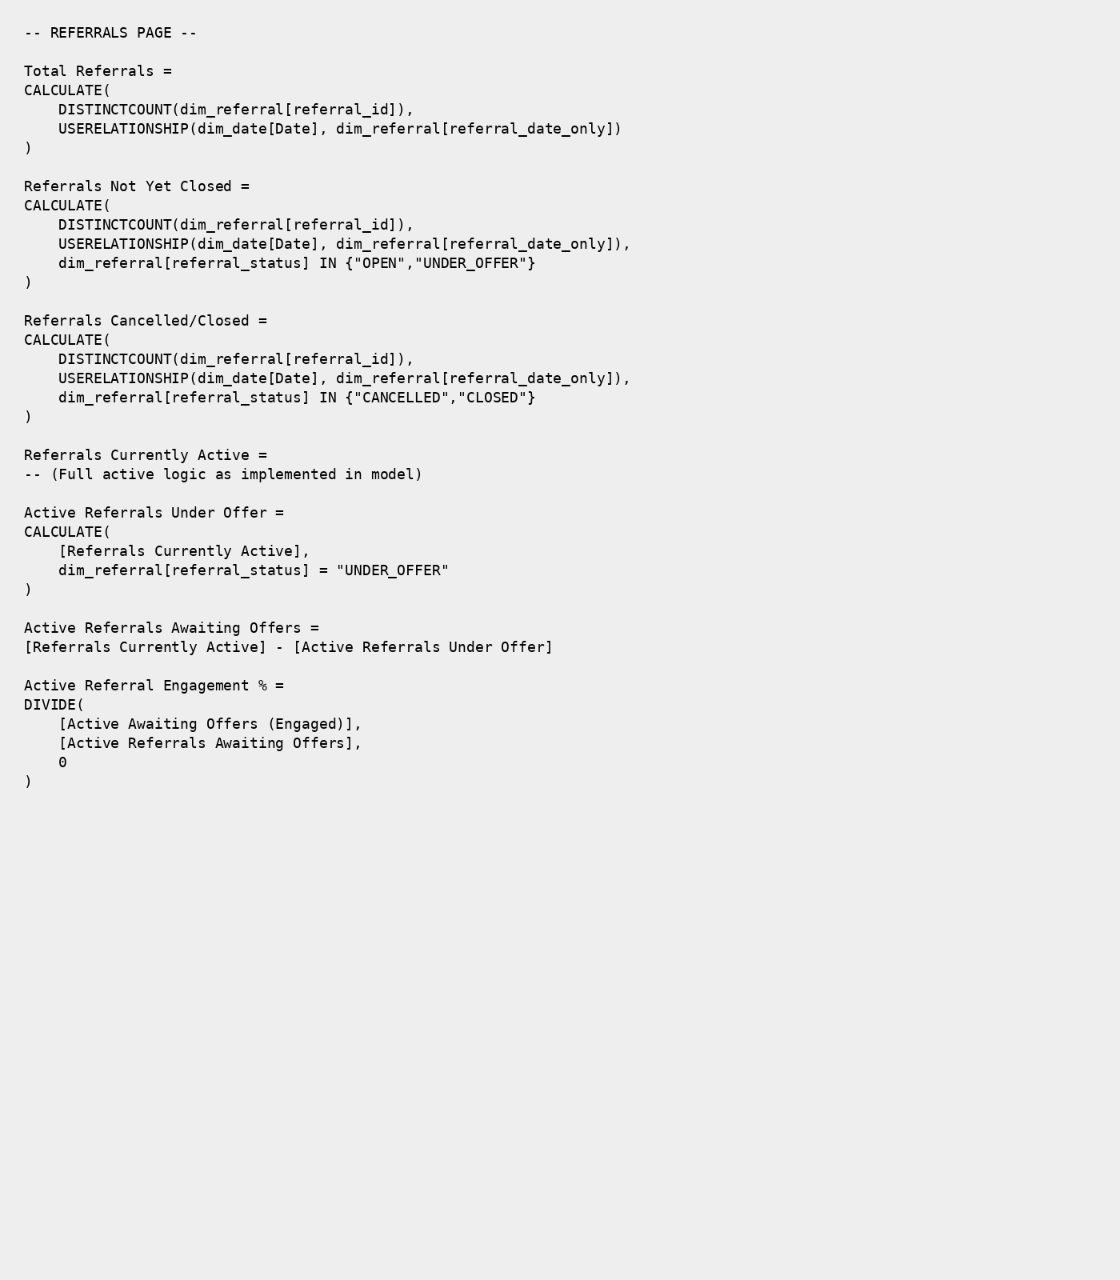

Visual interpretation
- The donut chart shows referrals by placement type, supporting understanding of demand across provision types such as Supported Accommodation, Residential and Fostering.
- The monthly activity chart shows the movement of referrals by status over time.
- The cancellation/closure reason chart provides insight into why referrals are not progressing.
- The gender cards provide a simple demographic split of referrals, supporting equality monitoring and service planning conversations.
Important interpretation: these measures are flow-based. They show referrals created within the selected period and grouped by current status; they are not a historical point-in-time backlog snapshot.

5. Page Breakdown – Offers Overview
This page translates referral demand into market response. It shows how many active referrals have received offers, how many are awaiting a first offer, the total number of offers made, provider participation, offer outcomes and the split between spot and framework offers.
KPI | Displayed value | Plain-English definition
Referrals Currently Open/Active | 106 | Open referrals forming the active referral population.
Referrals With One or More Offers | 55 | Open referrals that have received at least one offer.
Referrals Awaiting First Offer | 51 | Open referrals that have not yet received an offer.
Active/Open Referrals that have had Offers | 52% | Percentage of open referrals with at least one offer.
Total Offers Made | 427 | Distinct latest non-draft offers.
Avg Offers per Referral | 2.74 | Average offers made across the full referral population.
No. Providers Who Made Offers | 86 | Distinct providers linked to valid non-draft latest offers.
Avg Offers per Provider | 4.97 | Average number of valid offers per active provider.
Pending Offers | 377 | Distinct latest offers currently Pending.
Successful Offers | 10 | Distinct latest offers accepted.
Unsuccessful Offers | 40 | Distinct latest terminal offers not accepted.
Offers in Draft Status | 162 | Distinct latest draft offers shown on this page view.

Key DAX logic
Referrals With One or More Offers =
CALCULATE(
DISTINCTCOUNT(dim_referral[referral_id]),
USERELATIONSHIP(dim_date[Date], dim_referral[referral_date_only]),
dim_referral[referral_status] = "OPEN",
dim_referral[referral_id] IN
CALCULATETABLE(
VALUES(fact_referral_offer[referral_id]),
fact_referral_offer[has_offer] = TRUE()
)
)
Referrals Awaiting First Offer =
CALCULATE(
DISTINCTCOUNT(dim_referral[referral_id]),
USERELATIONSHIP(dim_date[Date], dim_referral[referral_date_only]),
dim_referral[referral_status] = "OPEN",
NOT dim_referral[referral_id] IN
CALCULATETABLE(
VALUES(fact_referral_offer[referral_id]),
fact_referral_offer[has_offer] = TRUE()
)
)
Active/Open Referrals that have had Offers =
DIVIDE([Referrals with One or More Offers], [Referrals Currently Open/Active], 0)
Total Offers Made =
CALCULATE(
DISTINCTCOUNT(fact_offer[offer_id]),
fact_offer[Is_Latest_Record] = 1,
KEEPFILTERS(dim_offer_status[offer_status_label] <> "Draft")
)
Avg Offers per Referral = DIVIDE([Total Offers Made], [Total Referrals], 0)
Avg Offers per Provider = DIVIDE([Total Offers Made], [No. Providers Who Made Offers], 0)
No. Providers Who Made Offers =
VAR ValidOfferIDs =
CALCULATETABLE(
VALUES(fact_offer[offer_id]),
fact_offer[Is_Latest_Record] = 1,
KEEPFILTERS(dim_offer_status[offer_status_label] <> "Draft")
)
RETURN
CALCULATE(
DISTINCTCOUNT(fact_referral_offer[provider_id]),
TREATAS(ValidOfferIDs, fact_referral_offer[offer_id]),
NOT ISBLANK(fact_referral_offer[provider_id])
)
Successful Offers =
CALCULATE(
DISTINCTCOUNT(fact_offer[offer_id]),
fact_offer[Is_Latest_Record] = 1,
dim_offer_status[offer_status_label] = "Accepted"
)
Unsuccessful Offers =
CALCULATE(
DISTINCTCOUNT(fact_offer[offer_id]),
fact_offer[Is_Latest_Record] = 1,
dim_offer_status[is_terminal] = TRUE(),
dim_offer_status[is_accepted] = FALSE()
)
Offers in Draft Status =
CALCULATE(
DISTINCTCOUNT(fact_offer[offer_id]),
fact_offer[Is_Latest_Record] = 1,
dim_offer_status[offer_status_label] = "Draft"
)

Visual interpretation
- The provider ranking chart shows which providers have submitted the highest number of offers.
- The spot versus framework chart compares offer route by placement type.
- Referral-level metrics and offer-level metrics are deliberately separated to avoid confusing the number of referrals being responded to with the number of individual offers made.

6. Page Breakdown – Pending Offers in Progress
This page provides an operational view of live pending offers. It highlights the volume of pending offers and segments them by age so that users can identify healthy activity, emerging risk, backlog and critical delays.
KPI | Displayed value | Ageing category | Definition
Pending Offers | 377 | Total live pending | Distinct latest offers with Pending status.
Pending Offers 0–7 Days | 60 | Healthy Pipeline | Pending offers aged 0 to 7 days.
Pending Offers 8–14 Days | 66 | At Risk | Pending offers aged more than 7 and up to 14 days.
Pending Offers 15–30 Days | 95 | Outside Timeframe | Pending offers aged more than 14 and up to 30 days.
Pending Offers 30+ Days | 156 | Critical Pipeline | Pending offers aged more than 30 days.

Key DAX logic
Pending Offers (in Progress) =
CALCULATE(
DISTINCTCOUNT(fact_offer[offer_id]),
fact_offer[Is_Latest_Record] = 1,
dim_offer_status[offer_status_label] = "Pending"
)
Pending Offers 0–7 Days =
CALCULATE(
DISTINCTCOUNT(fact_offer[offer_id]),
fact_offer[Is_Latest_Record] = 1,
dim_offer_status[offer_status_label] = "Pending",
fact_offer[Pending Offer Age (Days)] <= 7
)
Pending Offers 8–14 Days =
CALCULATE(
DISTINCTCOUNT(fact_offer[offer_id]),
fact_offer[Is_Latest_Record] = 1,
dim_offer_status[offer_status_label] = "Pending",
fact_offer[Pending Offer Age (Days)] > 7 &&
fact_offer[Pending Offer Age (Days)] <= 14
)
Pending Offers 15–30 Days =
CALCULATE(
DISTINCTCOUNT(fact_offer[offer_id]),
fact_offer[Is_Latest_Record] = 1,
dim_offer_status[offer_status_label] = "Pending",
fact_offer[Pending Offer Age (Days)] > 14 &&
fact_offer[Pending Offer Age (Days)] <= 30
)
Pending Offers 30+ Days =
CALCULATE(
DISTINCTCOUNT(fact_offer[offer_id]),
fact_offer[Is_Latest_Record] = 1,
dim_offer_status[offer_status_label] = "Pending",
fact_offer[Pending Offer Age (Days)] > 30
)

Visual interpretation
- The pending offers by days chart shows the distribution of pending offers across the ageing buckets.
- The provider-level stacked bar chart focuses on offers beyond the healthy 0–7 day window, helping users identify providers with at-risk, outside timeframe or critical pending offers.
- The ageing buckets reconcile to the total pending offers: 60 + 66 + 95 + 156 = 377.

7. Page Breakdown – Draft Offers
This page identifies draft offers that have not progressed into live offer activity. It is designed to reveal hidden backlog and distinguish between drafts that have never been touched after creation and drafts that have become inactive over time.
KPI | Displayed value | Plain-English definition
Offers in Draft Status | 166 | Distinct latest offers currently in Draft status.
Draft No Activity Since Creation | 165 | Draft offers where last modified date matches offer creation date.
Draft Offers With Activity Since Creation | 1 | Draft offers with evidence of activity after creation.
Drafts No Activity for 14+ Days | 114 | Drafts with no modification for 14 or more days, including blanks.
Draft With No Activity Since Creation (%) | 99% | Percentage of draft offers never updated after creation.

Key DAX logic
Offers in Draft Status =
CALCULATE(
DISTINCTCOUNT(fact_offer[offer_id]),
fact_offer[Is_Latest_Record] = 1,
dim_offer_status[offer_status_label] = "Draft"
)
Draft No Activity Since Creation =
CALCULATE(
DISTINCTCOUNT(fact_offer[offer_id]),
fact_offer[Is_Latest_Record] = 1,
dim_offer_status[offer_status_label] = "Draft",
FILTER(
fact_offer,
NOT ISBLANK(fact_offer[offer_date]) &&
NOT ISBLANK(fact_offer[last_modified_date]) &&
LEFT(fact_offer[last_modified_date], 10) = LEFT(fact_offer[offer_date], 10)
)
)
Draft Offers With Activity Since Creation = [Offers in Draft Status] - [Draft No Activity Since Creation]
Drafts No Activity for 14+ Days =
COALESCE(
CALCULATE(
DISTINCTCOUNT(fact_offer[offer_id]),
fact_offer[Is_Latest_Record] = 1,
dim_offer_status[offer_status_label] = "Draft",
FILTER(
fact_offer,
ISBLANK(fact_offer[last_modified_date]) ||
DATEDIFF(DATEVALUE(LEFT(fact_offer[last_modified_date], 10)), TODAY(), DAY) >= 14
)
),
0
)
Draft With No Activity Since Creation (%) =
DIVIDE([Draft No Activity Since Creation], [Offers in Draft Status], 0)

Visual interpretation
- The draft ageing chart shows how long offers have remained in Draft status.
- Higher counts in older bands indicate stalled or potentially abandoned work.
- This page is particularly useful for identifying process behaviour, not just outcomes.

8. Page Breakdown – IPA Overview
This page tracks the final workflow from accepted offers into IPA creation and completion. It helps users identify whether the issue sits at accepted offers not entering the IPA process, or created IPAs not progressing through to completion.
KPI | Displayed value | Plain-English definition
Successful Offers | 10 | Distinct latest offers with Accepted status.
IPA Created | 6 | Distinct IPA records created.
IPA Completed | 1 | IPAs where both provider and local authority signature flags are TRUE.
IPAs Pending Completion | 5 | Created IPAs that have not yet been fully completed.
Offers Awaiting IPA Creation | 4 | Accepted offers still awaiting IPA creation.
Accepted Offers to IPA Creation | 60% | Percentage of accepted offers that have progressed to IPA creation.
Offers Still to Progress to IPA | 40% | Percentage of accepted offers still awaiting IPA creation.
IPAs Created to Completion | 17% | Percentage of created IPAs that are completed.
Successful Offers to Completed IPAs | 10% | Percentage of accepted offers that have become completed IPAs.

Key DAX logic
Successful Offers =
CALCULATE(
DISTINCTCOUNT(fact_offer[offer_id]),
fact_offer[Is_Latest_Record] = 1,
dim_offer_status[offer_status_label] = "Accepted"
)
IPA Created =
DISTINCTCOUNT(fact_ipa[ipa_id])
IPA Completed =
CALCULATE(
DISTINCTCOUNT(fact_ipa[ipa_id]),
fact_ipa[signed_by_provider] = TRUE(),
fact_ipa[signed_by_local_authority] = TRUE()
)
IPAs Pending Completion =
[IPA Created] - [IPA Completed]
Offers Awaiting IPA Creation =
CALCULATE(
DISTINCTCOUNT(fact_offer[offer_id]),
fact_offer[Is_Latest_Record] = 1,
dim_offer_status[offer_status_label] = "Accepted",
fact_offer[Awaiting IPA Creation Flag] = 1
)
Accepted Offers to IPA Creation =
DIVIDE(
DISTINCTCOUNT(fact_ipa[offer_id]),
[Successful Offers]
)
Offers Still to Progress to IPA =
DIVIDE(
[Offers Awaiting IPA Creation],
[Successful Offers],
0
)
IPAs Created to Completion =
DIVIDE(
[IPA Completed],
[IPA Created],
0
)
Successful Offers to Completed IPAs =
DIVIDE(
[IPA Completed],
[Successful Offers],
0
)

Visual interpretation
- The workflow funnel shows progression from Successful Offers to IPA Created, IPAs Pending Completion and IPA Completed.
- The funnel makes the two-stage workflow gap visible: accepted offers awaiting IPA creation and created IPAs awaiting completion.
- The IPAs Pending Completion table should show created IPA records that are not yet fully signed by both parties.
- The Offers Awaiting IPA Creation table acts as an operational follow-up list for accepted offers that have not yet entered the IPA process.
Page narrative: Out of 10 successful offers, 60% have progressed to IPA creation. However, only 1 IPA (10%) has been fully completed, with 5 remaining pending completion. A further 40% of successful offers have not yet entered the IPA process, highlighting delays both in converting accepted offers into IPAs and in progressing IPAs through to completion.

9. Technical Definitions and Modelling Notes
Term | Meaning in this dashboard
Referral-level measure | A measure counted using dim_referral[referral_id]. These metrics describe cases/referrals rather than individual offer records.
Offer-level measure | A measure counted using fact_offer[offer_id]. One referral may have multiple offers.
IPA-level measure | A measure counted using fact_ipa[ipa_id]. These metrics describe IPA records and signature completion.
Is_Latest_Record = 1 | Ensures only the latest/current version of an offer is counted, preventing historical status records from inflating totals.
USERELATIONSHIP | Activates the reporting relationship between the date table and referral date field for the measure calculation.
Pending Offer Age (Days) | Numeric age field used to allocate pending offers into operational ageing buckets.
Draft no activity since creation | A draft offer where the last modified date is the same as the creation date at day level.
IPA completed | An IPA where both signed_by_provider and signed_by_local_authority are TRUE.
IPAs Pending Completion | Created IPA records that have not yet reached the completed state.

10. Overall Interpretation for the 14 Local Authorities
The dashboard should be read as a pathway rather than as a set of isolated pages. The Referrals Overview establishes demand. The Offers Overview shows market response. The Pending Offers page identifies live operational backlog. The Draft Offers page identifies hidden or stalled activity before offers become live. The IPA Overview shows whether accepted offers are being converted into created and completed placement agreements.
This structure allows each Local Authority to understand the same workflow using a common set of definitions and consistent logic. It also supports more meaningful comparison and discussion because the measures are transparent and the calculation approach is documented.
Workflow stage | Dashboard page | What users should look for
Referral demand | Referrals Overview | Volume, current status, placement type and closure reasons.
Market response | Offers Overview | How many open referrals have offers and which providers are active.
Pending progression | Pending Offers | Ageing pending offers and provider-level backlog.
Draft inactivity | Draft Offers | Drafts that have not progressed or are inactive.
Formalisation | IPA Overview | Accepted offers converting into created and completed IPAs.

11. Suggested Use of This Pack
This document can be shared alongside the Power BI dashboard so that users understand not only what each visual shows, but also how the underlying metrics are calculated. It is intended to support data transparency, common interpretation and informed discussion across the 14 Local Authorities.
When reviewing the dashboard, users should apply the date and placement filters consistently and should be mindful of the difference between referral-level, offer-level and IPA-level metrics. Where figures appear different between pages, this is often because the measures are deliberately counted at different grains.

12. Closing Note
I have created this dashboard and supporting logic pack to make the WMPP reporting approach clear, repeatable and easier to discuss across authorities. The aim is to provide both a user-friendly overview and a transparent technical reference so that colleagues can understand how each metric has been derived and how it should be interpreted.

